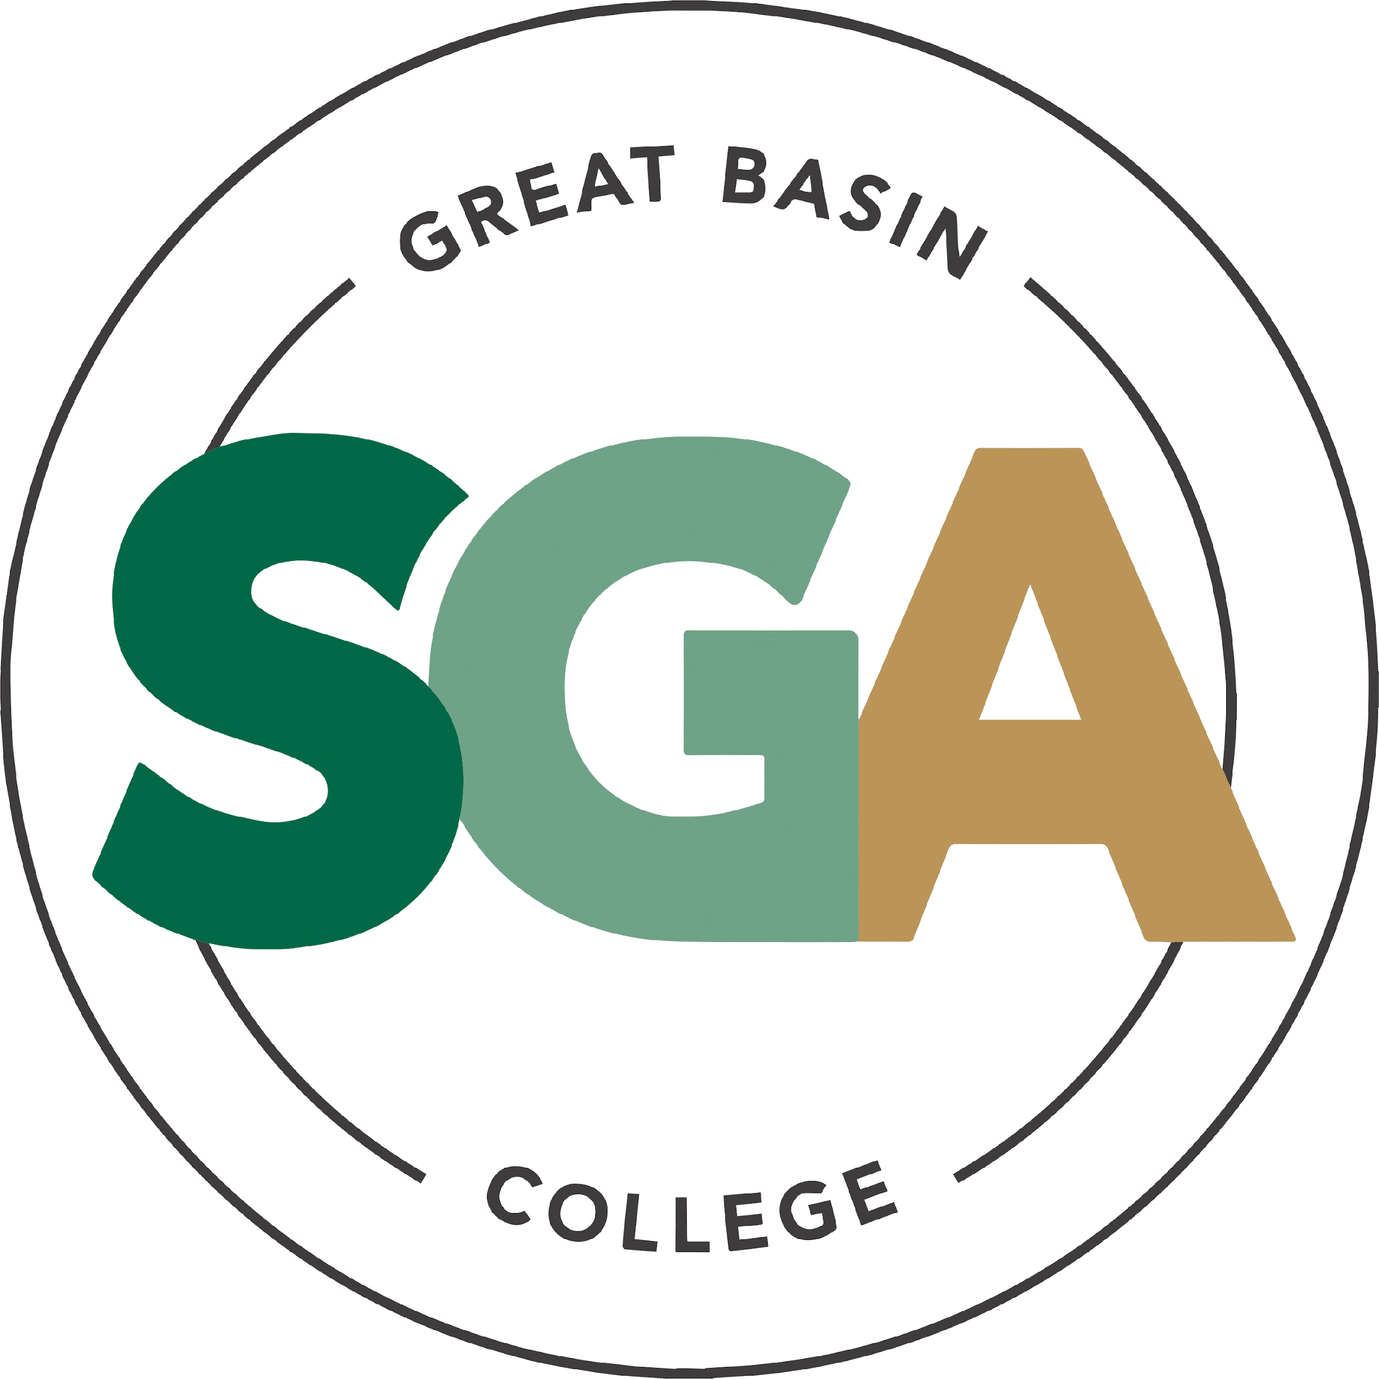

STUDENT GOVERNMENT ASSOCIATION (SGA)

AGENDA
April 7, 2026
3:00 PM

VIDEO OR TELEPHONE CONFERENCE CONNECTION FROM THE MEETING SITE TO: 1500 COLLEGE PARKWAY; SGA OFFICE, LEONARD CENTER FOR STUDENT LIFE, GREAT BASIN COLLEGE CAMPUS, ELKO NV 89801
A VIDEO CONFERENCE CONNECTION WILL BE MADE FROM THE MEETING SITE TO ALL OTHER CAMPUS LOCATIONS.
THE PUBLIC MAY ATTEND THE MEETING AND PROVIDE PUBLIC COMMENT AT THIS SITE. PUBLIC COMMENT MAY ALSO BE SUBMITTED VIA ONLINE BY EMAILING SGA@GBCNV.EDU. COMMENTS MUST BE RECEIVED BY 5 PM PST THE DAY PRIOR TO THE MEETING. MEMBERS OF THE PUBLIC WISHING TO VIEW OR ATTEND THE MEETING MAY DO SO VIA ZOOM AT:
https://gbcnv-edu.zoom.us/j/84298011629?pwd=u7cz48zIwBHMP2dBEHkFAQ9r3DEMQR.1

EXECUTIVE MEMBERS:

STORM RAINE, PRESIDENT
JULIA STOKES, VICE PRESIDENT
DENIELLE KIRKMAN, SECRETARY

SENATORS:

IAN MITCHEL, ELKO

MUHAMMED SALIKHOV, ELKO

YULIANA MENDEZ-BARAJAS, ELKO

JULIAN SOSA, ELKO

DIVINE JACOBSON, ELKO

DAVID BERNADINO-LOPEZ, ELKO

ELIZABETH NASH, ELY

CATHERINE HANSON, ELY

CATHERINE COLE, ONLINE

TERILYN MARINO, ONLINE

SOFIA MAYORGA, WINNEMUCCA

DIEGO ESQUIVEL, WINNEMUCCA

CALVIN COWAN, PAHRUMP

AVA COFFILL, PAHRUMP

NOTE: Below is an agenda of all items scheduled to be considered. Notification is hereby provided that items on the agenda may be taken out of the order presented, two or more agenda items may be combined for consideration, and an agenda item may be removed from the agenda or discussion relating to an item on the agenda may be delayed at any time.
The agenda and any supporting material, including materials submitted after the posting of this agenda but before the meeting, may be accessed on the Internet by visiting the SGA page of the GBC website: Great Basin College: Student Life - Meetings.
In accordance with NRS241.020(6), supporting materials that are submitted to the Student Government Association (SGA) will be made available in advance of the meeting. Reasonable efforts will be made to assist and accommodate physically disabled persons attending the meeting. Please call the Office for Students with Disabilities (775) 327-2336 in advance so that arrangements may be made.

ROLL CALL

- Roll call of members and any persons serving as a proxy for a member will be taken.
Estimated Time: 5 minutes

PUBLIC COMMENT INFORMATION ONLY

Public comment will be taken during this agenda item. No action may be taken on a matter raised under this item until the matter is included on an agenda as an item on which action may be taken. Comments will be limited to two minutes per person. Persons making comment will be asked to begin by stating their name for the record and to spell their last name. The SGA President may elect to allow additional public comment on a specific agenda item when that agenda item is being considered.

Pursuant to NRS 241.023, members of the public may also participate in the meeting by submitting written public comment messages via email to james.kendall@gbcnv.edu. Written statements received by 4:30 p.m. on THURSDAY, April 2, 2026, will be distributed to SGA members and included in the permanent meeting record and names of those who provide public comment via email will be announced at the meeting, however messages will no longer be read into the record. Members of the public may attend the meeting and provide public comment.

In accordance with Attorney General Opinion No. 00-047 (April 27, 2001), as restated in the Attorney General’s Open Meeting Law Manual, the President may prohibit comment if the content of that comment is a topic that is not relevant to, or within the authority of, the SGA, or if the content is willfully disruptive of the meeting by being irrelevant, repetitious, slanderous, offensive, inflammatory, irrational or amounting to personal attacks or interfering with the rights of other speakers.

Estimated Time: 5 minutes

APPROVAL OF AGENDA POSSIBLE ACTION
A Request is made for approval of the GBC SGA Agenda for the meeting on 4/7/2026.

APPROVAL OF PREVIOUS MINUTES POSSIBLE ACTION
A Request is made for approval of the GBC SGA Minutes for the meeting on 3/31/2026.
Estimated Time: 1 minutes

PRESIDENT’S REPORT INFORMATION ONLY

SGA PRESIDENT RAINE will discuss current SGA events and activities as SGA President

Estimated Time: 5 minutes

VICE PRESIDENT’S REPORT INFORMATION ONLY

SGA VICE PRESIDENT STOKES will discuss current SGA events and activities as SGA Vice President.
Estimated Time: 2 minutes

SECRETARY’S REPORT INFORMATION ONLY

SGA SECRETARY KIRKMAN will discuss current SGA events and activities as SGA Secretary.
Estimated Time: 2 minutes

STUDENT ADVOCATE’S REPORT INFORMATION ONLY

Student Advocate, JAMES KENDALL, will discuss current SGA events and items concerning SGA.
Estimated Time: 5 minutes

SENATOR REPORTS INFORMATION ONLY

Senators from each location will discuss their current and future events: Elko, Ely, Online, Winnemucca, and Pahrump.

Estimated Time: 10 minutes

COMMITTEE REPORTS INFORMATION ONLY

Chairs of each Committee (Graduation, Mascot, and Amendments) will discuss their progress of their committees.
Estimated Time: 10 minutes

Unfinished Business

POSSIBLE BEATS AND BITES COMMITTEE INFORMATION ONLY

President Raine would like to discuss creating a committee to have SGA take on Beats and Bites from now on.

NEW BUSINESS POSSIBLE ACTION

- SUCCULENTS & SANDWICHES FOR EARTH DAY WITH JESSICA ORTIZ
April 22nd is Earth Day, and it has become an annual SGA event in Elko. Last year, the event was well-received, with strong participation from students who enjoyed picking succulents. This has been approved by the events committee, and we want to have this on each campus concurrently. Allocation of plants from the budget will be billed to each campus accordingly. She is requesting $700 dollars for food and prize funding.
Estimated Time: Less than 5 minutes

- SGA PINS WITH JESSICA ORTIZ
We would like to purchase SGA pins for everyone to have. She is requesting $600 for food and prize funding.
Estimated Time: Less than 5 minutes

- PAHRUMP BEAUTIFICATION PROJECT WITH SENATOR COWAN
This funding request will come from the PVC SGA budget. It is intended to enhance the front of our campus by installing shade cloths and purchasing the necessary equipment and supplies. Our maintenance staff will complete the installation, which will significantly reduce costs.
This project will create an outdoor space for students to study, host events, and relax. With the ongoing improvements to our center, this space is both needed and beneficial for student engagement. He is requesting $4000 for supply funding.
Estimated Time: Less than 5 minutes

- GIFT BAGS FOR GRADUATES WITH SENATOR COWAN
I am requesting $3,000 from the Pahrump Valley SGA Funds Account to assemble gift bags for graduating students at the Pahrump Valley Center. I will work with Senator Coffill to put together these bags for students who will be walking at the Pahrump commencement on May 9. Proposed items include GBC alumni stickers, a T-shirt, a GBC pen, a Ram plushie, and candy. The estimated value is $60 per bag of GBC swag. He is requesting $3000 from food and prize funding.
Estimated Time: Less than 5 minutes

- LLC GRADUATION SUPPLIES WITH SENATOR COWAN
I am requesting $500 in funding from the PVC SGA account to assist and collaborate with Winnemucca in providing cake, punch, and approved supplies for the LCC students’ graduation. I started this tradition when I first became a Senator, and SGA has provided funding to help cover the cost of celebrating these students, and I would like to continue that tradition. He is requesting $500 for food and prize funding.
Estimated Time: Less than 5 minutes

PUBLIC COMMENT INFORMATION ONLY

Public comment will be taken during this agenda item. No action may be taken on a matter raised under this item until the matter is included on an agenda as an item on which action may be taken. Comments will be limited to two minutes per person. Persons making comment will be asked to begin by stating their name for the record and to spell their last name. The SGA President may elect to allow additional public comment on a specific agenda item when that agenda item is being considered.

Pursuant to NRS 241.023, members of the public may also participate in the meeting by submitting written public comment messages via email to james.kendall@gbcnv.edu. Written statements received by 4:30 p.m. on THURSDAY, April 2, 2026, will be distributed to SGA members and included in the permanent meeting record, and names of those who provide public comment via email will be announced at the meeting, messages will no longer be read into the record. Members of the public may attend the meeting and provide public comment.

In accordance with Attorney General Opinion No. 00-047 (April 27, 2001), as restated in the Attorney General’s Open Meeting Law Manual, the President may prohibit comment if the content of that comment is a topic that is not relevant to, or within the authority of, the SGA, or if the content is willfully disruptive of the meeting by being irrelevant, repetitious, slanderous, offensive, inflammatory, irrational or amounting to personal attacks or interfering with the rights of other speakers.

Estimated Time: 5 minutes
Posted in accordance with Nevada Open Meeting Law (NRS Ch. 241), at the following locations:
GBC, Berg Hall, 1500 College Parkway, Elko, NV 89801
Nevada Public Notice Website - https://notice.nv.gov
GBC SGA Website - Great Basin College: Student Life - Meetings.

14. Adjournment INFORMATION ONLY

