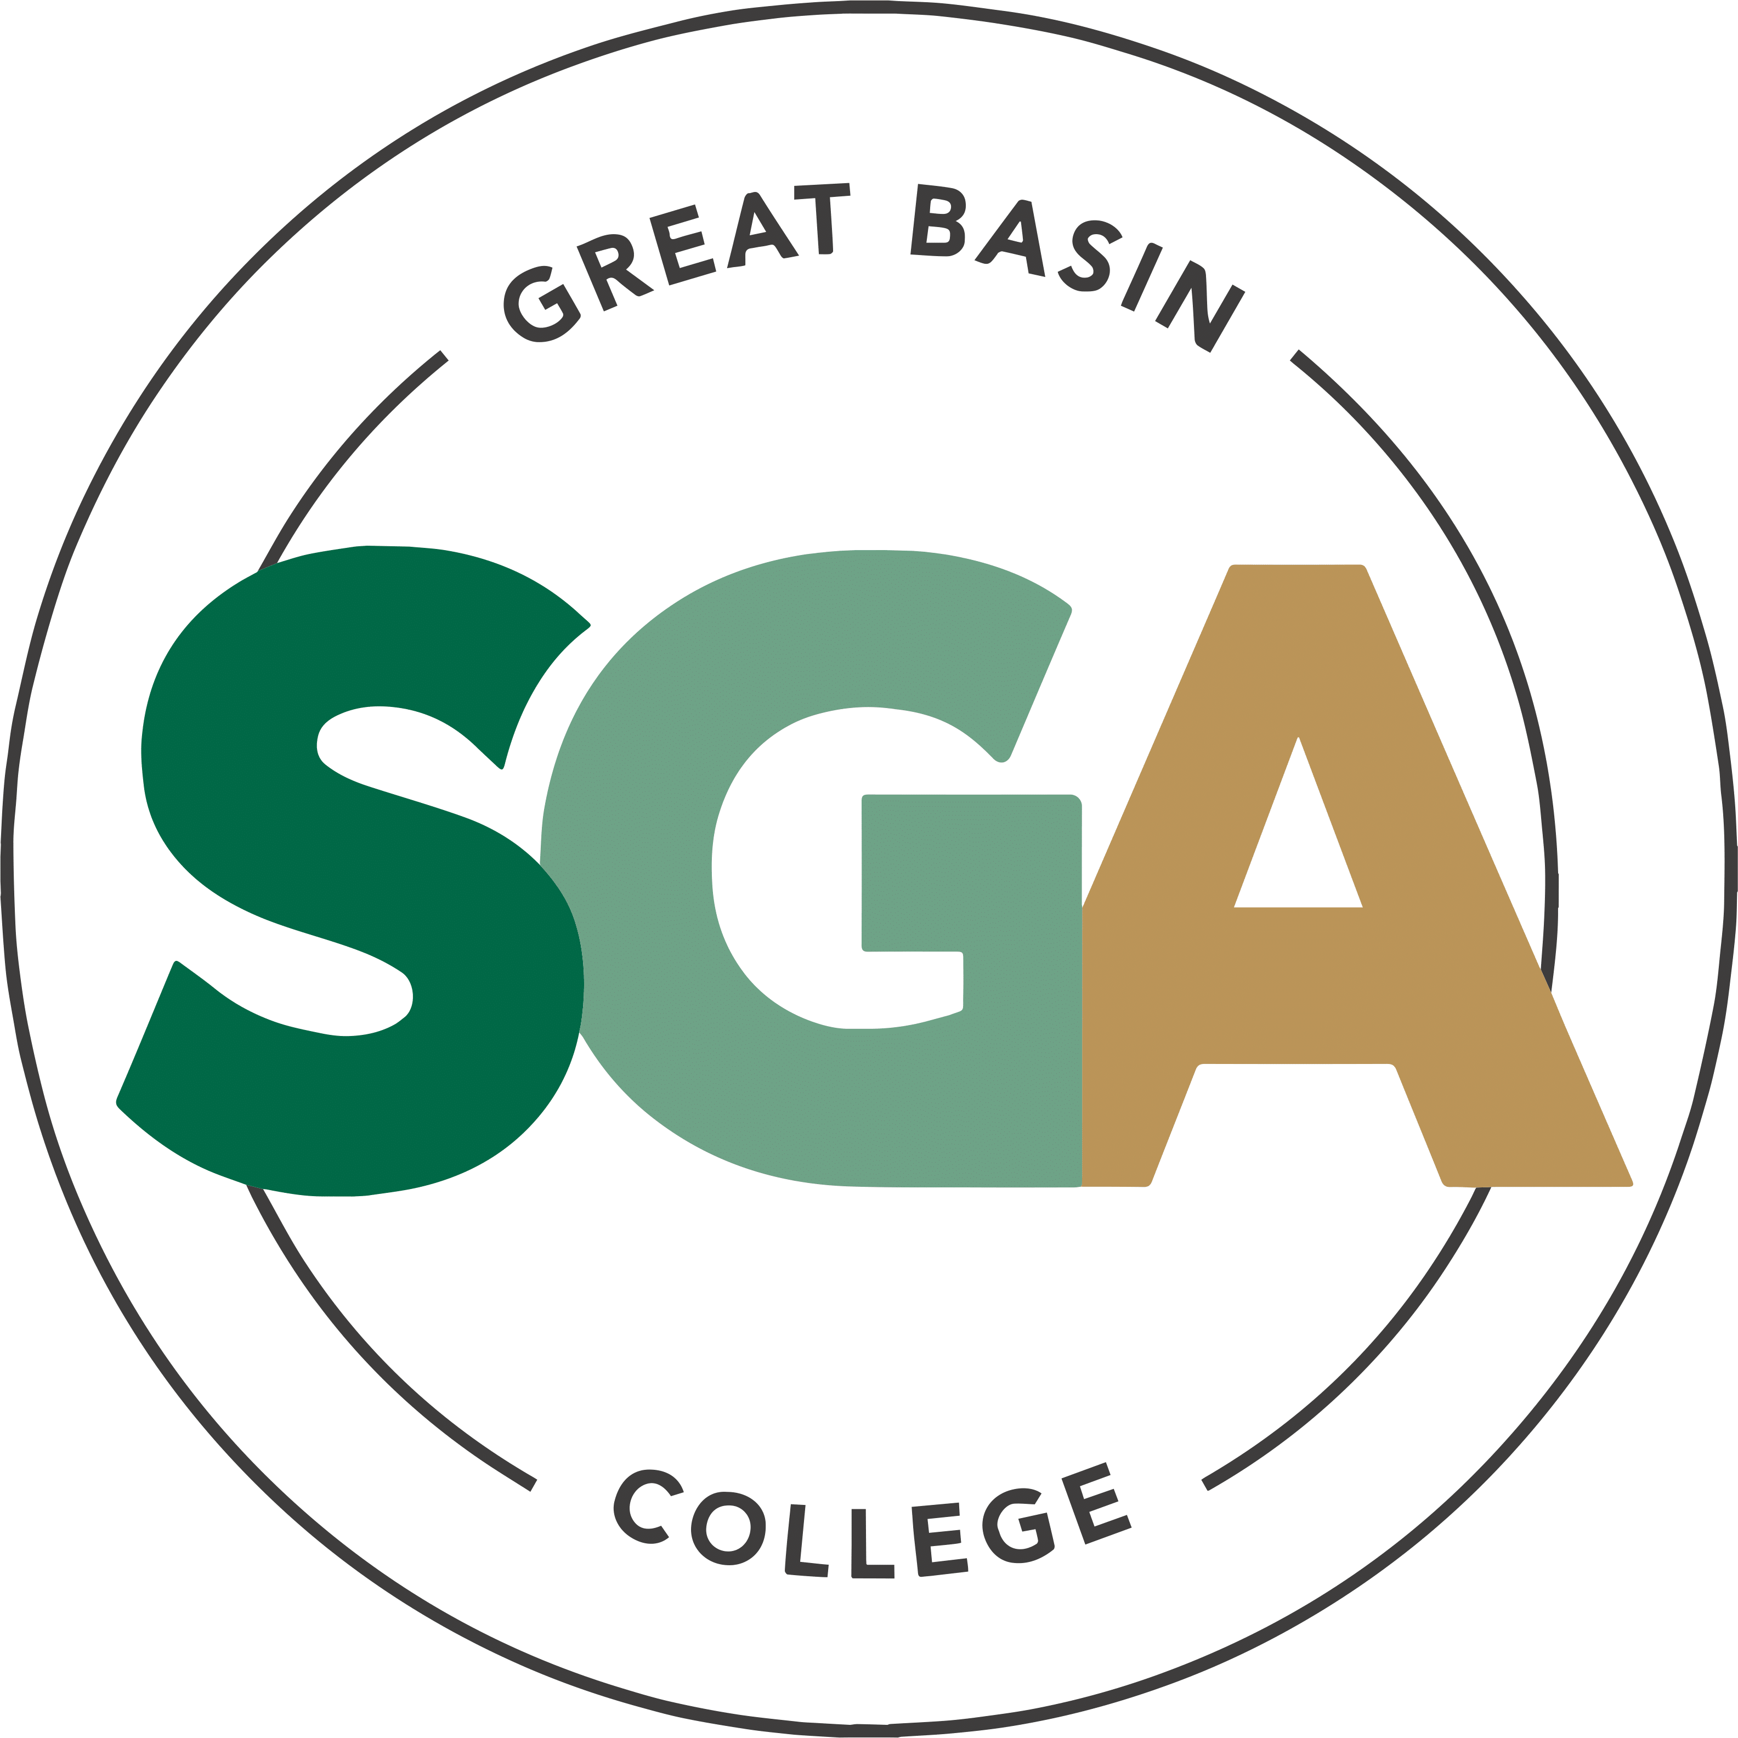

STUDENT GOVERNMENT ASSOCIATION (SGA)

AGENDA
March 31, 2026
3:00PM

VIDEO OR TELEPHONE CONFERENCE CONNECTION FROM THE MEETING SITE TO: 1500 COLLEGE PARKWAY; SGA OFFICE, LEONARD CENTER FOR STUDENT LIFE, GREAT BASIN COLLEGE CAMPUS, ELKO NV 89801
A VIDEO CONFERENCE CONNECTION WILL BE MADE FROM THE MEETING SITE TO ALL OTHER CAMPUS LOCATIONS.
THE PUBLIC MAY ATTEND THE MEETING AND PROVIDE PUBLIC COMMENT AT THIS SITE. PUBLIC COMMENT MAY ALSO BE SUBMITTED VIA ONLINE BY EMAILING SGA@GBCNV.EDU. COMMENTS MUST BE RECEIVED BY 5 PM PST THE DAY PRIOR TO THE MEETING. MEMBERS OF THE PUBLIC WISHING TO VIEW OR ATTEND THE MEETING MAY DO SO VIA ZOOM AT:
https://gbcnv-edu.zoom.us/j/84298011629?pwd=u7cz48zIwBHMP2dBEHkFAQ9r3DEMQR.1

EXECUTIVE MEMBERS:

STORM RAINE, PRESIDENT
JULIA STOKES, VICE PRESIDENT
DENIELLE KIRKMAN, SECRETARY

SENATORS:

IAN MITCHEL, ELKO

MUHAMMED SALIKHOV, ELKO

YULIANA MENDEZ-BARAJAS, ELKO

JULIAN SOSA, ELKO

DIVINE JACOBSON, ELKO

DAVID BERNADINO-LOPEZ, ELKO

ELIZABETH NASH, ELY

CATHERINE HANSON, ELY

CATHERINE COLE, ONLINE

TERILYN MARINO, ONLINE

SOFIA MAYORGA, WINNEMUCCA

DIEGO ESQUIVEL, WINNEMUCCA

CALVIN COWAN, PAHRUMP

AVA COFFILL, PAHRUMP

IMPORTANT INFORMATION ABOUT THE AGENDA AND PUBLIC MEETING

NOTE: Below is an agenda of all items scheduled to be considered. Notification is hereby provided that items on the agenda may be taken out of the order presented, two or more agenda items may be combined for consideration, and an agenda item may be removed from the agenda or discussion relating to an item on the agenda may be delayed at any time.
The agenda and any supporting material, including materials submitted after the posting of this agenda but before the meeting, may be accessed on the Internet by visiting the SGA page of the GBC website: Great Basin College: Student Life - Meetings.
In accordance with NRS241.020(6), supporting materials that are submitted to the Student Government Association (SGA) will be made available in advance of the meeting. Reasonable efforts will be made to assist and accommodate physically disabled persons attending the meeting. Please call the Office for Students with Disabilities (775) 327-2336 in advance so that arrangements may be made.

ROLL CALL

Roll call of members and any persons serving as a proxy for a member will be taken.
Estimated Time: 5 minutes

PUBLIC COMMENT INFORMATION ONLY

Public comment will be taken during this agenda item. No action may be taken on a matter raised under this item until the matter is included on an agenda as an item on which action may be taken. Comments will be limited to two minutes per person. Persons making comment will be asked to begin by stating their name for the record and to spell their last name. The SGA President may elect to allow additional public comment on a specific agenda item when that agenda item is being considered.

Pursuant to NRS 241.023, members of the public may also participate in the meeting by submitting written public comment messages via email to james.kendall@gbcnv.edu. Written statements received by 4:30 p.m. on THURSDAY, March 26, 2026, will be distributed to SGA members and included in the permanent meeting record and names of those who provide public comment via email will be announced at the meeting, however messages will no longer be read into the record. Members of the public may attend the meeting and provide public comment.

In accordance with Attorney General Opinion No. 00-047 (April 27, 2001), as restated in the Attorney General’s Open Meeting Law Manual, the President may prohibit comment if the content of that comment is a topic that is not relevant to, or within the authority of, the SGA, or if the content is willfully disruptive of the meeting by being irrelevant, repetitious, slanderous, offensive, inflammatory, irrational or amounting to personal attacks or interfering with the rights of other speakers.

Estimated Time: 5 minutes

APPROVAL OF AGENDA POSSIBLE ACTION
A Request is made for approval of the GBC SGA Agenda for the meeting on 3/31/2026.
Estimated Time: 1 minutes

APPROVAL OF MINUTES POSSIBLE ACTION
A Request is made for approval of the GBC SGA Minutes for the meeting on 3/17/2026.
Estimated Time: 1 minutes

PRESIDENT’S REPORT INFORMATION ONLY

SGA PRESIDENT RAINE will discuss current SGA events and activities as SGA President
Estimated Time: 5 minutes

VICE PRESIDENT’S REPORT INFORMATION ONLY

SGA VICE PRESIDENT STOKES will discuss current SGA events and activities as SGA Vice President.
Estimated Time: 2 minutes

SECRETARY’S REPORT INFORMATION ONLY

SGA SECRETARY KIRKMAN will discuss current SGA events and activities as SGA Secretary.
Estimated time: 2 minutes

STUDENT ADVOCATE’S REPORT INFORMATION ONLY

Student Advocate, JAMES KENDALL, will discuss current SGA events and items concerning SGA.
Estimated Time: 5 minutes

SENATOR REPORTS INFORMATION ONLY

Senators from each location will discuss their current and future events: Elko, Ely, Online, Winnemucca, and Pahrump.
Estimated Time: 10 minutes

Upcoming items

D&D CLUB RECOGNITION WITH JAMES KENDALL POSSIBLE ACTION

The D&D Club is requesting to be a recognized student organization. The packet has been reviewed by the Executive Board. They are requesting funding of $300.

Estimated Time: Less than 5 Minutes

STUDENT AWARD CEREMONY WITH JESSICA ORTIZ POSSIBLE ACTION
The annual Student Awards Ceremony will be held. 28 students will be awarded. There is 1 Regent’s Award Recipient and the 2 SGA Scholarship winners. We are usually asked to provide food and the award, but this year, they are only requesting that we fund the awards. James is requesting $750 for food and prize funding.
Estimated Time: 5-10 MINUTES.

SGA GRADUATION COMMITTEE WITH JAMES KENDALL POSSIBLE ACTION
This item is to establish a ceiling of funds to be used for all Graduation Gifts sponsored by the SGA. The funds will be billed according to the allotment of gifts to each campus. He is requesting $5500 in food and prize funding.
Estimated Time: 5-10 MINUTES

SGA RETREAT FUNDS WITH JESSICA ORTIZ POSSIBLE ACTION
This item is to allocate funds for the SGA retreat. Jessica is requesting $200 in supply funding and $1400 in food and prize funding.

Estimated Time: Less than 5 Minutes

NEW BUSINESS INFORMATION ONLY
Items for consideration at future meetings may be suggested. Any discussion of an item under “New Business” is limited to description and clarification of the subject matter of the item, which may include the reasons for the request, and no substantive discussion may occur at this meeting on new business items in accordance with the Nevada Open Meeting Law (NRS 241.010 et seq.).

Estimated Time: 5 minutes

PUBLIC COMMENT INFORMATION ONLY

Public comment will be taken during this agenda item. No action may be taken on a matter raised under this item until the matter is included on an agenda as an item on which action may be taken. Comments will be limited to two minutes per person. Persons making comment will be asked to begin by stating their name for the record and to spell their last name. The SGA President may elect to allow additional public comment on a specific agenda item when that agenda item is being considered.

Pursuant to NRS 241.023, members of the public may also participate in the meeting by submitting written public comment messages via email to james.kendall@gbcnv.edu. Written statements received by 4:30 p.m. on THURSDAY, March 26, 2026, will be distributed to SGA members and included in the permanent meeting record, and names of those who provide public comment via email will be announced at the meeting, messages will no longer be read into the record. Members of the public may attend the meeting and provide public comment.

In accordance with Attorney General Opinion No. 00-047 (April 27, 2001), as restated in the Attorney General’s Open Meeting Law Manual, the President may prohibit comment if the content of that comment is a topic that is not relevant to, or within the authority of, the SGA, or if the content is willfully disruptive of the meeting by being irrelevant, repetitious, slanderous, offensive, inflammatory, irrational or amounting to personal attacks or interfering with the rights of other speakers.

Estimated Time: 5 minutes
Posted in accordance with the Nevada Open Meeting Law (NRS Ch. 241), at the following locations:
GBC, Berg Hall, 1500 College Parkway, Elko, NV 89801
Nevada Public Notice Website - https://notice.nv.gov
GBC SGA Website - Great Basin College: Student Life - Meetings.

